CHAPTER 1:
PROJECT OVERVIEW

- PROJECT OVERVIEW

The problem with physical keys has even bigger implication for companies in the business of mail or goods delivery. These companies need access to many different private buildings. Doors spread over a wide geographical areas and govern by many different owners. Personnel need to carry keys for each single door on the delivery route. Carrying all this keys is a hassle in the daily use and the vulnerable to theft. But just as important, route, personnel and locks change over time, making it a resource consuming operation to assure that all personnel have the right key at the right time.
- Proposed System
To tackle the above issue, we proposed to replace physical keys with digital keys that:
- Can easily be distributed to user
- Can only be used by the correct user
- Can be specialized for each user so each key will be unique
- Can be restricted to a given time or a date range
- Allows many keys to be contained in the same small device.

We proposed to use the mobile phone equipped with Android Platform as the mobile device. First, mobile phones are getting very common and bringing your mobile with is u is becoming as natural as bringing your keys. Second, mobile phones are becoming increasingly open to third party developer, while the hardware at the same time is getting more and more powerful. This makes mobile phones a suitable platform for uses beyond making and receiving phone calls. In this system we are also providing sms alerts for gas leakage and theft alert adding more security.

CHAPTER 2:
INTRODUCTION AND MOTIVATIOIN

2. INTRODUCTION & MOTIVATION :

Mobile phones were intended as the name describes for one basic function: portable communication, but the fast technological development turned it to a very important multi-purpose personal device serving as camera, radio, audio and video player, personal organizer, internet and mail browser, also as geographical positioning device and much more. At the same, we use keys in every step in our daily life to unlock various doors and gates, our car, home, office, store and in every one of such places there are more internal doors. In the big organizations, factories, business of mail or goods delivery, managing a key system is complicated process and mostly lacks proper security arrangements.
Wireless communication has been a great quantitative and qualitative jump in information management, allowing access and interchange without a physical wire connection. Wireless transmission of voice and data has a continuous evolution arising to new standards, like Bluetooth wifi.

The physical key is an integrated and natural part of most people's life. It is a well-tested part of most people's life. It is a well tested and well known technology. But it also has flaws. In particular, for companies needing access to many different private building with its own lock and key, the distribution of keys to the right employee at the time is a complex and costly affair. Furthermore, carrying a large number of keys is a burden for each employee and increases the chance of keys getting stolen or lost.

2.1 THEORY BEHIND THE PROJECT
Home/office security is top priority of all concerned. Today there are plenty of home/office security products to ensure your family’s security completely. Home/office security is the most significant one for every home/office owner either in an individual house or an apartment. For that different security systems are available. Those are smart cards, RFID’s, I-button, password and biometrics etc.
Access control is the ability to permit or deny the use of a particular resource by a particular entity. Access control system can be used in managing physical resources (such as a movie theater, to which only ticket holders should be admitted), logical resources (a bank account, with a limited number of people authorized to make a withdrawal), or digital resources, for these kinds of things.
The main idea of designing digital locking system is to provide many modern security features than mechanical lock; here android app is used to enter the password. If that password matches to the password that was already stored in flash of the controller then the dc motor is activated and the door will be opened. If it does not matched then the motor remains deactivated. In addition it also provides sms alerts for gas leakage and theft alert.

2.2 PROBLEM STATEMENT:
The problem with physical keys has even bigger implication for companies in the business of mail or goods delivery. This companies need access to many different private buildings. Doors spread over a wide geographical areas and govern by many different owners. Personnel need to carry keys for each single door on the delivery route. Carrying all this keys is a hassle in the daily use and the vulnerable to theft. But just as important, route, personnel and locks change over time, making it a resource consuming operation to assure that all personnel have the right key at the right time.

To tackle the above issue, we proposed to replace physical keys with digital keys that:
- Can easily be distributed to user
- Can only be used by the correct user
- Can be specialized for each user so each key will be unique
- Can be restricted to a given time or a date range
- Allows many keys to be contained in the same small device.

We proposed to use the mobile phone equipped with Android Platform as the mobile device. First, mobile phones are getting very common and bringing your mobile with is becoming as natural as bringing your keys. Second, mobile phones are becoming increasingly open to third party developer, while the hardware at the same time is getting more and more powerful. This makes mobile phones a suitable platform for uses beyond making and receiving phone calls.

2.3 NEED FOR PROJECT

Security is the main concern for everyone. Everyone wants to live securely in his/her house. Everybody wants themselves to keep safe or secure from various incidents like theft in their house or accidents caused due to LPG gas leakage .Now days many times we hear news about house robbery or theft in some houses, bungalows, flats. These robberies or thefts take place when nobody is in house or in some cases we find that robbery take place even if people are in their houses. Another bad news we hear is about accidents are caused or blast happens because of LPG gas cylinder leakage. In house we find that LPG gas is commonly and widely used for cooking purpose. So in every kitchen we find that LPG gas cylinder is placed. However due to some reasons, LPG gas might leak from these cylinders. And because of this LPG gas leakage, fire might be ignited or it can even cause the LPG gas cylinder blast. Which can damage the house or in even worst situations, it can cause life threat to the person living inside the house. Another problem / fear are about fire in our house. Same with LPG gas leakage, if it is detected on time and if it is controlled on time then it can avoid a big accident. Also in case of robbery it would be beneficial if we can get some alert. Let’s take an example that we are out of our home and theft is going on in our house. In such case if we are intimated about theft then we can inform our neighbors, then they can create some noise or take some appropriate action so that this theft can be avoided. Let’s take another problem; sometimes key of our home is lost. If we do not replace our lock and if these keys are found by thieves then it can cause robbery. We all know that duplicate key can be created within few minutes and also key duplication is easy. These are the disadvantages of traditional locking system which uses a key and a lock. To overcome all the above stated disadvantages of existing system we have designed a GSM based home security system. It can avoid these undesirable situations, hazardous conditions like LPG gas leakage and theft alerts.

CHAPTER 3:
ANALYSIS AND DESIGN

3. ANALYSIS & DESIGN

  - SOFTWARE DEVELOPMENT

AGILE PROCESS:
In 1980’s the heavy weight, plan based software development approach was used to develop any software product. In this approach too many things are done which were not directly related to software product being produced. This approach was rigid. That means if requirements get changed then rework was essential. Hence new methods were proposed in 1990’s which are Known as processes.
The agile processes are the light weight methods are people based rather than plan based methods. The agile process forces the development team to focus on software itself rather than design and documentation. The agile process believes in iterative method. The aim of agile process is to deliver the working model of software quickly to the customer.

Set of principles of Agile process
1.Customer Involvement: The customer should be involved in the software development process. The customer specifies the software requirements and evaluates each iteration of the system.
2.Incremental change: Software is developed in increments. Each increment must be evaluated by the customer and customer should suggest in the system if any. These changes must be implemented in the next increment.
3.Assume simplicity: The software system to be developed should be simple and the complexity of the system should be implemented.
4.People are important than process: The skill of he people should be exploited. Instead of following rigid prescribed process, people should get the liberty to develop their own ideas and their own working style.
5.Embrace change: Requirements evolve overtime. If any changes occur in requirements or in design then system should accommodate those chan.

3.2 FLOW OF PROJECT

3.2.1 PRELIMINARY SURVEY

ANDROID SDK
Android software development is the process by which new applications are created for the Android operating system. Applications are usually developed in the Java programming language using the Android Software Development Kit, but other development tools are available. As of October 2012, more than 700,000 applications have been developed for Android, with over 25 billion downloads. A June 2011 research indicated that over 67% of mobile developers used the platform, at the time of publication. In Q2 2012; around 105 million units of Android smart phones were shipped which acquires a total share of 68% in overall smart phones sale till Q2 2012.
The Android software development kit (SDK) includes a comprehensive set of development tools.^{[6]} These include a debugger, libraries, a handset emulator based on QEMU, documentation, sample code, and tutorials. Currently supported development platforms include computers running Linux (any modern desktop Linux distribution), Mac OS X 10.5.8 or later, Windows XP or later; for the moment one can develop Android software on Android itself by using [AIDE - Android IDE - Java, C++] app and [Android java editor] app. The officially supported integrated development environment (IDE) is Eclipse using the Android Development Tools (ADT) Plugin, though Intelli J IDEA IDE (all editions) fully supports Android development out of the box, and Net Beans IDE also supports Android development via a plugin. Additionally, developers may use any text editor to edit Java and XML files, then use command line tools (Java Development Kit and Apache Ant are required) to create, build and debug Android applications as well as control attached Android devices (e.g., triggering a reboot, installing software package(s) remotely).
Enhancements to Android's SDK go hand in hand with the overall Android platform development. The SDK also supports older versions of the Android platform in case developers wish to target their applications at older devices. Development tools are downloadable components, so after one has downloaded the latest version and platform, older platforms and tools can also be downloaded for compatibility testing.
Android applications are packaged in .apk format and stored under /data/app folder on the Android OS (the folder is accessible only to the root user for security reasons). APK package contains .dexfiles(compiled byte code files called Dalvikexecutables), resource files, etc.
FEATURES OF ANDROID:
Handset layouts
The platform is adaptable to larger, VGA, 2D graphics library, 3D graphics library based on OpenGL ES 2.0 specifications, and traditional smartphone layouts.

- Storage
SQLite, a lightweight relational database, is used for data storage purposes.

- Connectivity
Android supports connectivity technologies including GSM/EDGE, IDEN, CDMA, EV-DO, UMTS, Bluetooth, Wi-Fi, LTE, NFC and WiMAX.

- Messaging
SMS and MMS are available forms of messaging, including threaded text messaging and Android Cloud To Device Messaging (C2DM) and now enhanced version of C2DM, Android Google Cloud Messaging (GCM) is also a part of Android Push Messaging service.

- Multiple language support
Android supports multiple languages.

- Web browser
The web browser available in Android is based on the open-source WebKit layout engine, coupled with Chrome's V8 JavaScript engine. The browser scores 100/100 on the Acid3 test on Android 4.0.

- Java support
While most Android applications are written in Java, there is no Java Virtual Machine in the platform and Java byte code is not executed. Java classes are compiled into Dalvik executables and run on Dalvik, a specialized virtual machine designed specifically for Android and optimized for battery-powered mobile devices with limited memory and CPU. J2ME support can be provided via third-party applications.

- Media support
Android supports the following audio/video/still media formats: WebM, H.263, H.264, AAC, HE-AAC (in 3GP or MP4container), MPEG-4 SP, AMR, AMR-WB (in 3GP container), MP3, MIDI, OggVorbis, FLAC, WAV, JPEG, PNG, GIF, BMP, WebP.

- Streaming media support
RTP/RTSP streaming (3GPP PSS, ISMA), HTML progressive download (HTML5 <video> tag). Adobe Flash Streaming (RTMP) and HTTP Dynamic Streaming are supported by the Flash plugin. Apple HTTP Live Streaming is supported by RealPlayer for Android, and by the operating system in Android 3.0 (Honeycomb).

- Additional hardware support
Android can use video/still cameras, touch screens, GPS, accelerometers, gyroscopes, barometers, magnetometers, dedicated gaming controls, proximity and pressure sensors, thermometers, accelerated 2D bit bits (with hardware orientation, scaling, pixel format conversion) and accelerated 3D graphics.

- Multi-touch
Android has native support for multi-touch which was initially made available in handsets such as the HTC Hero. The feature was originally disabled at the kernel level (possibly to avoid infringing Apple's patents on touch-screen technology at the time). Google has since released an update for the Nexus One and the Motorola Droid which enables multi-touch natively.

- Bluetooth
Supports A2DP, AVRCP, sending files (OPP), accessing the phone book (PBAP), voice dialing and sending contacts between phones. Keyboard, mouse and joystick (HID) support is available in Android 3.1+, and in earlier versions through manufacturer customizations and third-party applications.

- Video calling
Android does not support native video calling, but some handsets have a customized version of the operating system that supports it, either via the UMTS network (like the Samsung Galaxy S) or over IP. Video calling through Google Talk is available in Android 2.3.4 and later. Gingerbread allows Nexus S to place Internet calls with a SIP account. This allows for enhanced VoIP dialing to other SIP accounts and even phone numbers. Skype 2.1 offers video calling in Android 2.3, including front camera support. Users with the Google+ android app can video chat with other google+ users through hangouts.

- Multitasking
Multitasking of applications, with unique handling of memory allocation, is available.

- Accessibility
Built in text to speech is provided by Talk back for people with low or no vision. Enhancements for people with hearing disabilities is available as is other aids.

- Voice based features
Google search through voice has been available since initial release. Voice actions for calling, texting, navigation, etc. are supported on Android 2.2 onwards.As of Android 4.1, Google has expanded Voice Actions with the ability to talk back and read answers from Google's Knowledge Graph when queried with specific commands. The ability to control hardware has not yet been implemented.

- Tethering
Android supports tethering, which allows a phone to be used as a wireless/wired Wi-Fi hotspot. Before Android 2.2 this was supported by third-party applications or manufacturer customizations.

- Screen capture
Android supports capturing a screenshot by pressing the power and volume-down buttons at the same time.^{[16]} Prior to Android 4.0, the only methods of capturing a screenshot were through manufacturer and third-party customizations or otherwise by using a PC connection (DDMS developer's tool). These alternative methods are still available with the latest Android.

- External storage
Most Android devices include microSD slot and can read microSD cards formatted with FAT32, Ext3 or Ext4 file system. To allow use of high-capacity storage media such as USB flash drives and USB HDDs, many Android tablets also include USB 'A' receptacle. Storage formatted with FAT32 is handled by Linux Kernel VFAT driver, while 3rd party solutions are required to handle other popular file systems such as NTFS, HFS Plus and exFAT.

EMBEDED C:.
Embedded C is a set of language extensions for the C Programming language by the C Standards committee to address commonality issues that exist between C extensions for different embedded systems. Historically, embedded C programming requires nonstandard extensions to the C language in order to support exotic features such as fixed-point arithmetic, multiple distinct memory banks, and basic I/O operations.
In 2008, the C Standards Committee extended the C language to address these issues by providing a common standard for all implementations to adhere to. It includes a number of features not available in normal C, such as, fixed-point arithmetic, named address spaces, and basic I/O hardware addressing.
Embedded C use most of the syntax and semantics of standard C, e.g., main() function, variable definition, datatype declaration, conditional statements (if, switch. case), loops (while, for), functions, arrays and strings, structures and union, bit operations, macros, unions,etc

3.2.2 COST ANALYSIS
The overall project cost is less excluding GSM module and sensors. There is only the GSM module and sensors cost which is available in the market from 2000-3000 depending on the type of sensors.

3.2.3 PROCESS MODEL

WATERFALL MODEL:
This Waterfall model is used in our project. Essentially, it's a framework for software development in which development proceeds sequentially through a series of phases, starting with system requirements analysis and leading up to product release and maintenance. Feedback loops exist between each phase, so that as new information is uncovered or problems are discovered, it is possible to "go back" a phase and make appropriate modification. Progress "flows" from one stage to the next.

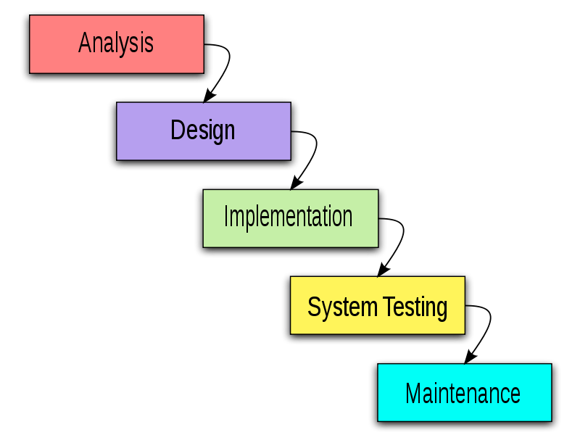
fig.3.1 Waterfall model

    - DATA FLOW DIAGRAMS

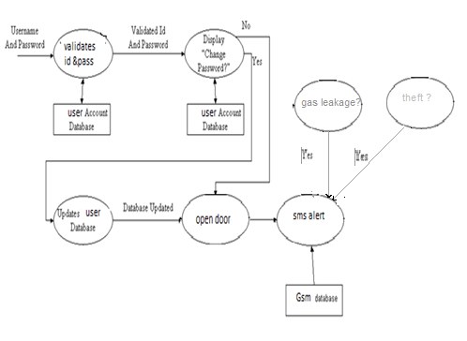
fig 3.2 data flow diagram

3.3UML DIAGRAMS

SEQUENCE DIAGRAM

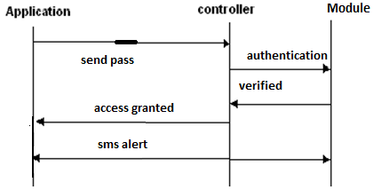

fig 3.3 Sequence Diagram

3.4 TECHNOLOGIES USED

3.4.1 HARDWARE & SOFTWARE REQUIREMENT

Hardware | Software
- GSM Module  - MQ4 Gas Sensor  - Infrared sensor  - Android Devices  Power Backup | - Android OS

3.4.2 INTRODUCTION TO PROGRAMMING TOOLS
1. KEIL COMPILER
General Description
Keil development tools for the 8051 Microcontroller Architecture support every level of software developer from the professional applications engineer to the student just learning about embedded software development. The industry- standard Keil C Compilers, Macro Assemblers, Debuggers, Real-time Kernels, Single-board Computers, and Emulators support all 8051 derivatives and help you get your projects completed on schedule
The Keil 8051 Development Tools are designed to solve the complex problems facing embedded software developers. When starting a new project, simply select the microcontroller you use from the Device Database and the μVision IDE sets all compiler, assembler, linker, and memory options for you. Numerous example programs are included to help you get started with the most popular embedded 8051 devices.
The Keil μVision Debugger accurately simulates on-chip peripherals (I²C, CAN, UART, SPI, Interrupts, I/O Ports, A/D Converter, D/A Converter, and PWM Modules) of your 8051 device.
Simulation helps you understand hardware configurations and avoids time wasted on setup problems. Additionally, with simulation, you can write and test applications before target hardware is available.
When you are ready to begin testing your software application with target hardware, use the MON51, MON390, MONADI, or FlashMON51 Target Monitors, the ISD51 In-System Debugger, or the ULINK USB-JTAG Adapter to download and test program code on your target system.
INTELLIGENT FAULT DETECTING SYSYEM FOR OPTICAL FIBER
It's been suggested that there are now as many embedded systems in everyday use as there are people on planet Earth. Domestic appliances from washing machines to TVs, video recorders and mobile phones, now include at least one embedded processor. They are also vital components in a huge variety of automotive, medical, aerospace and military systems. As a result, there is strong demand for programmers with 'embedded' skills, and many desktop developers are moving into this area.
Embedded C is designed for programmers with desktop experience in C, C++ or Java who want to learn the skills required for the unique challenges of embedded systems.

SIMULATOR:
The Keil hardware simulator for the popular 8051 microcontroller is on the CD-ROM so that readers can try out examples from the book - and create new ones - without requiring additional hardware. All code is written in C, so no assembly language is required. Industry-standard C compiler from Keil software is included on the CD-ROM, along with copies of code examples from the book to get you up and running very quickly. Key techniques required in all embedded systems are covered in detail, including the control of port pins and the reading of switches. A complete embedded operating system is presented, with full source code on the CD-ROM.
Achieve outstanding application performance on Intel processors using Intel C Compiler for Windows*, including support for the latest Intel multi-core processors. For out-of-the-box productivity, Intel C Compiler plugs into the Microsoft Visual Studio* development environment for IA-32 and features a preview plug-in to the Microsoft Visual Studio .NET environment
This provides information about the C compiler, including operating environments, standards conformance, organization of the compiler, and C- related programming tools. There are a number of tools available to aid in developing, maintaining, and improving your C programs. The two most closely tied to C, c scope and lint, are described in this book. In addition, a man page exists for each of these tools. Refer to the preface of this book for a list of all the associated man pages.
FEATURES:
- Nine basic data types, including 32-bit IEEE floating-point,
- Flexible variable allocation with bit, data, bdata, idata, xdata, and pdata memory types,
- Interrupt functions may be written in C,
- Full use of the 8051 register banks,
- Complete symbol and type information for source-level debugging,
- Use of AJMP and ACALL instructions,
- Bit-addressable data objects,
- Built-in interface for the RTX51 Real-Time Kernel, Support for dual data pointers on Atmel, AMD, Cypress, Dallas Semiconductor, Infineon, Philips, and Triscend microcontrollers,
- Support for the Philips 8xC750, 8xC751, and 8xC752 limited instruction sets, Support for the Infineon 80C517 arithmetic unit.

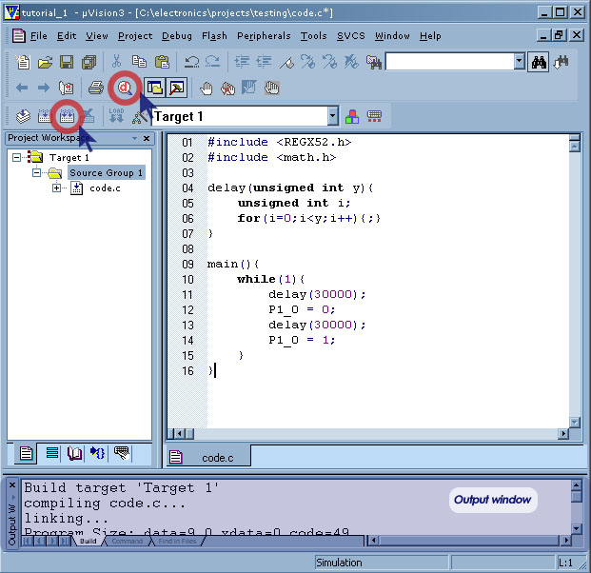
Fig 3.4 Screenshot of Keil µvision compiler

FLASH MAGIC
General Description
Semiconductors produce a range of Microcontrollers that feature both on-chip Flash memory and the ability to be reprogrammed using In-System Programming technology. Flash Magic is Windows software from the Embedded Systems Academy that allows easy access to all the ISP features provided by the devices. Flash Magic provides a clear and simple user interface to these features and more as described in the following sections. Under Windows, only one application may have access the COM Port at any one time, preventing other applications from using the COM Port. Flash Magic only obtains access to the selected COM Port when ISP operations are being performed. This means that other applications that need to use the COM Port, such as debugging tools, may be used while Flash Magic is loaded.
Features:
- Erasing the Flash memory (individual blocks or the whole device)
- Programming the Flash memory
- Modifying the Boot Vector and Status Byte Reading Flash memory
- Performing a blank check on a section of Flash memory Reading the signature bytes Reading and writing the security bits
- Direct load of a new baud rate (high speed communications) • Sending commands to place device in Boot-loader mode

- EAGLE SOFTWARE :

DRAWING A SCHEMATIC IN EAGLE

In this section you will learn how nets and buses are used in a drawing. You will then be able to create a schematic. To create an empty schematic, open a new drawing and enlarge the editor window.
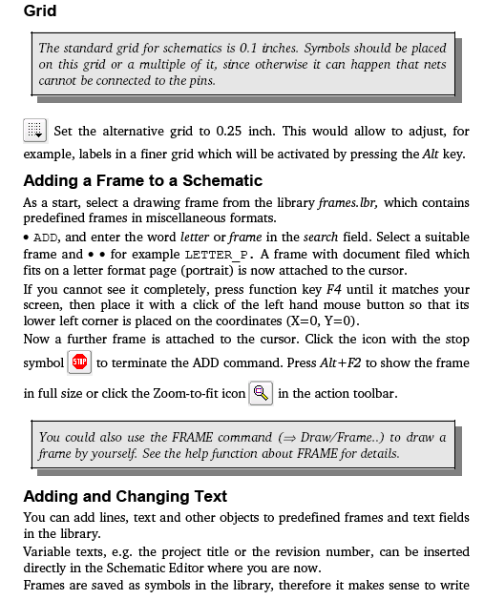

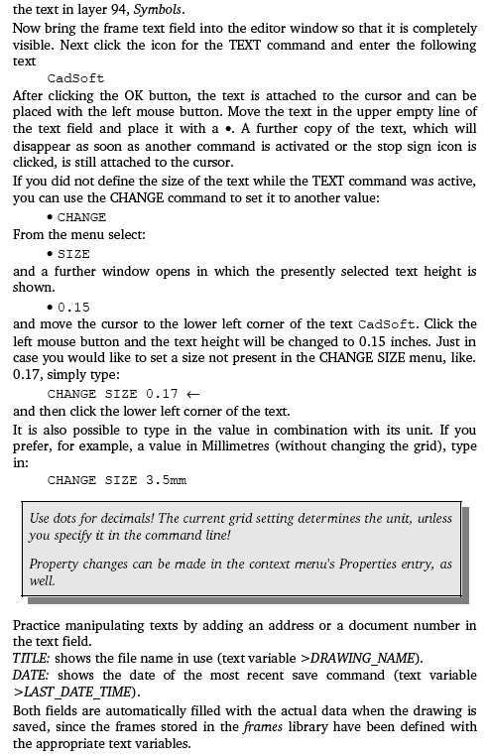
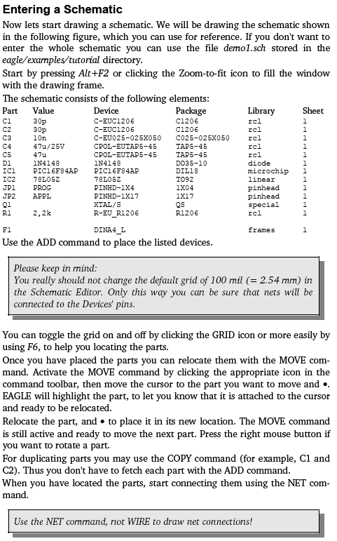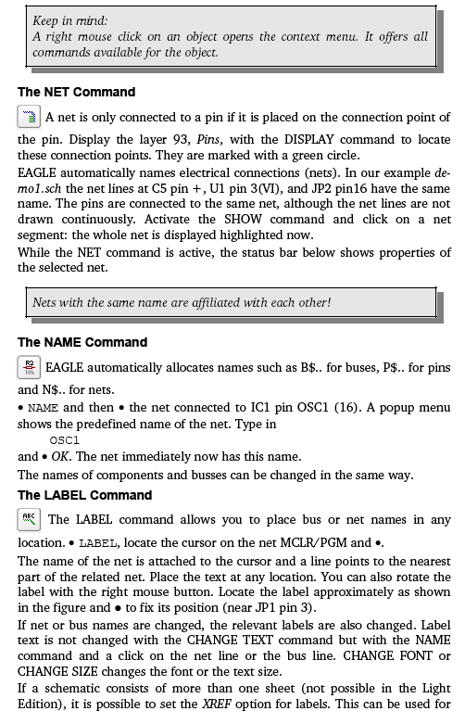

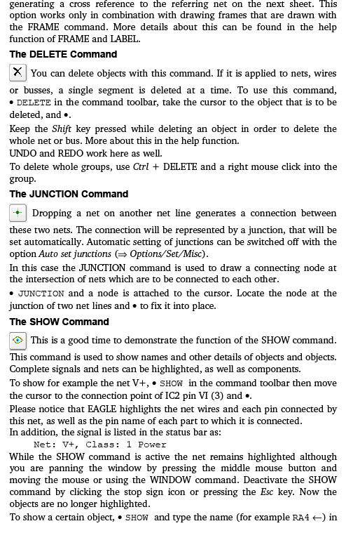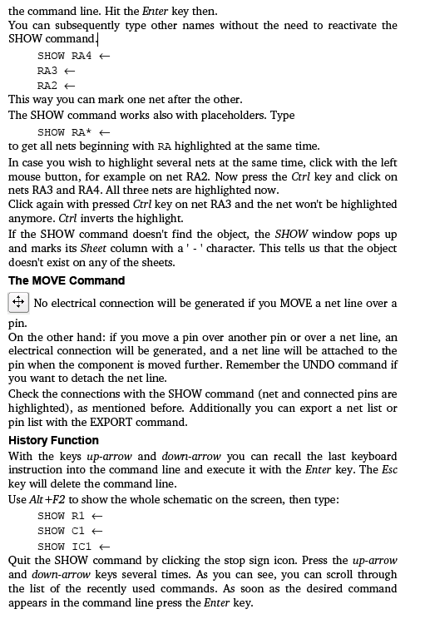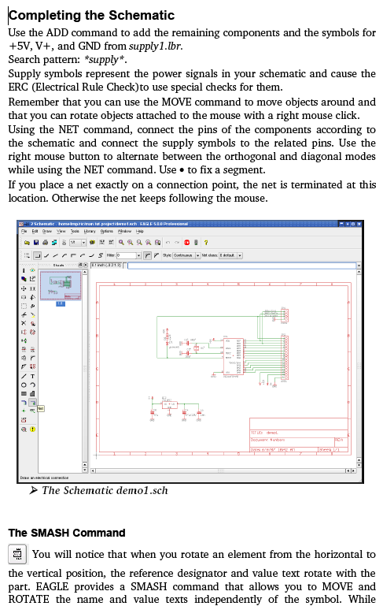
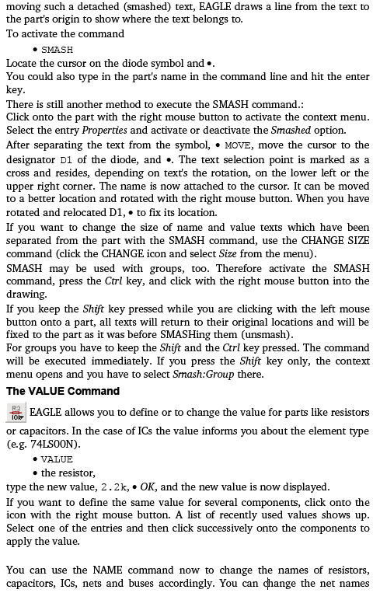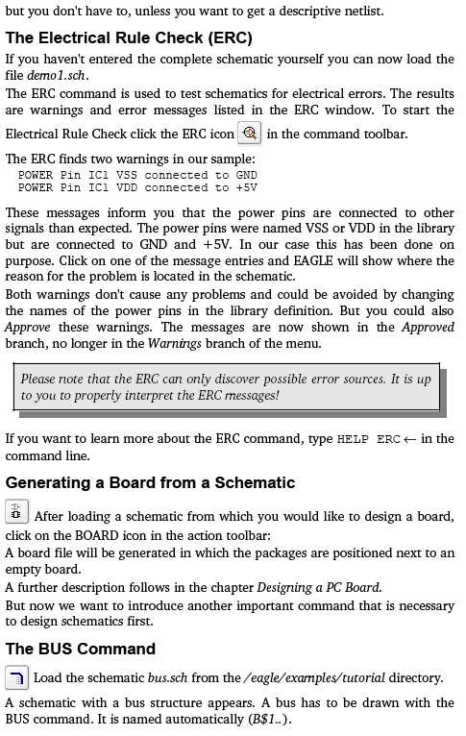
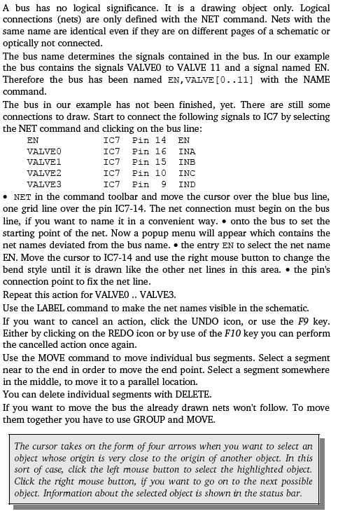

CHAPTER 4:
PROJECT TIME AND TASKS DISTRIBUTION

4 .PROJECT TIME & TASK DISTRIBUTION

4.1 TIMELINE CHART

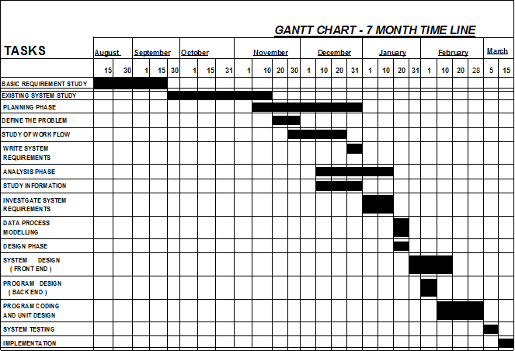

fig 4.1 Timeline Schedule

CHEPTER 5
IMPLEMENTATION

- IMPLEMENTATION

This project has 3 basic modules along with a GSM modem. GSM modem is used to send the SMS whenever there are changes in any of the three modules.
First module of this project detects if any person is entering inside the house. This feature is helpful at night time or whenever we are out of our home.
Second part of project serves the functionality of a door-latch opening using a password entered through keypad. As well as sending this data to a GSM modem through serial port. User can change this password anytime he/she wish using a keypad.
Third module uses LPG gas sensor to detect the gas leakage. If there is leakage then buzzer is turned on.

5.1 CIRCUIT DIAGRAM

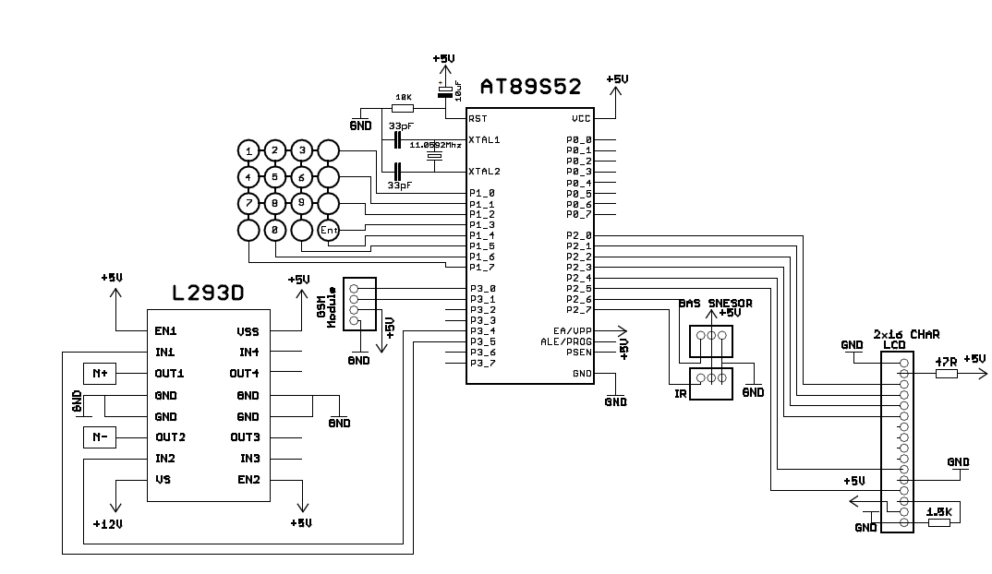

fig 5.1 Circuit Diagram

  - BLOCK DIAGRAM
:

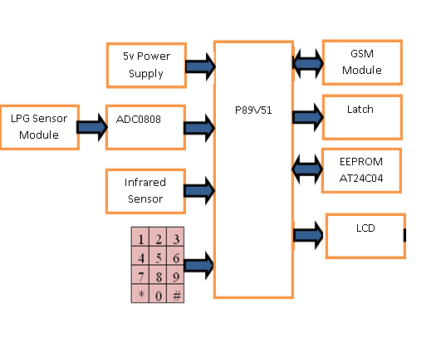

fig 5.2 Block Diagram

5.3. COMPONENTS DESCRIPTION
5.3.1 P89V51RD2 MICROCONTROLLER
The P89V51RD2 is a 80C51 microcontroller with 64 kB Flash and 1024 bytes of data RAM. A key feature of the P89V51RD2 is its X2 mode option. The design engineer can choose to run the application with the conventional 80C51 clock rate (12 clocks per machine cycle) or select the X2 mode (6 clocks per machine cycle) to achieve twice the throughput at the same clock frequency. Another way to benefit from this feature is to keep the same performance by reducing
The Flash program memory supports both parallel programming and in serial In-System Programming (ISP). Parallel programming mode offers gang-programming at high speed, reducing programming costs and time to market. ISP allows a device to be reprogrammed in the end product under software control. The capability to field/update the application firmware makes a wide range of applications possible.
The P89V51RD2 is also In-Application Programmable (IAP), allowing the Flash program memory to be reconfigured even while the application is running.
FEATURES
- 80C51 Central Processing Unit.
- 5 V Operating voltage from 0 MHz to 40 MHz
- 64 kB of on-chip Flash user code memory with ISP (In-System Programming) and IAP
- In-Application Programming
- Supports 12-clock (default) or 6-clock mode selection via software or ISP
- SPI (Serial Peripheral Interface) and enhanced UART
- PCA (Programmable Counter Array) with PWM and Capture/Compare functions
- Four 8-bit I/O ports with three high-current Port 1 pins (16 mA each)
- Three 16-bit timers/counters
- Programmable watchdog timer
- Eight interrupt sources with four priority levels
- Second DPTR register
- Low EMI mode (ALE inhibit)
- TTL- and CMOS-compatible logic levels
- Brown-out detection
- Low power modes
- Power-down mode with external interrupt wake-up
- Idle mode
- DIP40 packages

fig 5.3 Block Diagram of P89V51RD2

fig 5.4 Pin Diagram of P89V51RD2

5.3.2 MQ4 Gas Sensor
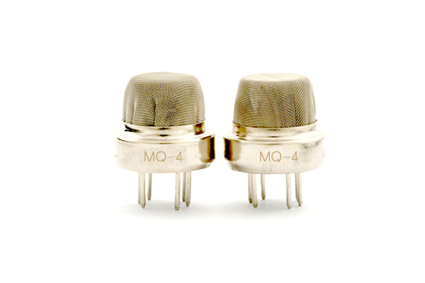
fig 5.5 MQ4 Gas Sensor
- Sensitive material of MQ-4 gas sensor is SnO2, which with lower conductivity in clean air. When the target combustible gas exist, The sensor's conductivity is more higher along with the gas concentration rising. Please use simple electrocircuit, Convert change of conductivity to
MQ-4 gas sensor has high sensitity to Methane, also to Propane and Butane. The sensor could be used to detect different combustible gas, especially Methane, it is with low cost and suitable for different application.
Character:
Good sensitivity to Combustible gas in wide range
High sensitivity to Natural gas
Long life and low cost
Simple drive circuit
Application:
Domestic gas leakage detector
Industrial Combustible gas detector
Portable gas detector

5.3.3 IR SENSOR TSOP17

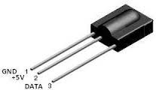

fig 5.6 IR Sensor TSOP17

DESCRIPTION

The TSOP17.. – series are miniaturized receivers for infrared remote control systems. PIN diode and preamplifier are assembled on lead frame, the epoxy package is designed as IR filter. The demodulated output signal can directly be decoded by a microprocessor. TSOP17.. is the standard IR remote control receiver series, supporting all major transmission codes.

Features
Photo detector and preamplifier in one package Internal filter for PCM frequency Improved shielding against electrical field disturbance TTL and CMOS compatibility Output active low
Low power consumption High immunity against ambient light Continuous data transmission possible (up to 2400 bps) Suitable burst length ≥10 cycles/burst

5.3.4 LIQUID CRYSTAL DISPLAY (LCD)

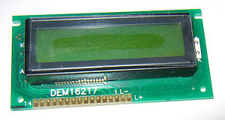
fig 5.7 LCD
A liquid crystal display (LCD) is a thin, flat electronic visual display that uses the light modulating properties of liquid crystals (LCs). LCs do not emit light directly.
They are used in a wide range of applications, including computer monitors, television, instrument panels, aircraft cockpit displays, signage, etc. They are common in consumer devices such as video players, gaming devices, clocks, watches, calculators, and telephones. LCDs have displaced cathode ray tube (CRT) displays in most applications. They are usually more compact, lightweight, portable, less expensive, more reliable, and easier on the eyes. They are available in a wider range of screen sizes than CRT and plasma displays, and since they do not use phosphors, they cannot suffer image burn-in.
LCDs are more energy efficient and offer safer disposal than CRTs. Its low electrical power consumption enables it to be used in battery-powered electronic equipment.
5.3.5 4X4 KEYPAD
A keypad is a set of buttons arranged in a block or "pad" which usually bear digits and other symbols and usually a complete set of alphabetical letters. If it mostly contains numbers then it can also be called a numeric keypad. Keypads are found on many alphanumeric keyboards and on other devices such as calculators, push-button telephones, combination locks, and digital door locks ,which require mainly numeric input.
In order to detect which key is pressed from the matrix, we make row lines low one by one and read the columns. Let’s say we first make Row1 low, and then read the columns. If any one of the key in row1 is pressed it will make the corresponding column as low i.e. if second key is pressed in Row1, then the column2 will be low. So we come to know that key
fig 5.8 4x4 Keyboard
INTERFACING THE KEYBOARD TO THE MICROCONTROLLER:
At the lowest level, keyboards are organized in a matrix of rows and columns. The CPU accesses both rows and columns through ports; therefore, with two 8-bit ports, an 8x8 matrix of keys can be connected to a microprocessor. When a key is pressed, a row and a column make a contact; otherwise, there is no connection between rows and columns. In IBM PC keyboards, a single microcontroller (consisting of a microprocessor, RAM and EPROM, and several PORTS all on a single chip) takes care of hardware and software interfacing of the keyboard, in such systems, it is the function of programs stored in the EPROM of the microcontroller to scan the keys continuously
SCANNING AND IDENTIFYING THE KEY:
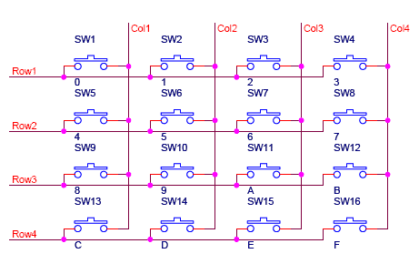
Fig shows a 4x4 matrix connected to two ports. The rows are connected to an output port and the columns are connected to an input port. If no key has been pressed, reading the input port will yield 1s for all columns since they are all connected to high (Vcc). If all the rows are grounded and a key is pressed, one of the columns will have 0 since the pressed provides the path to ground. It is the function of the microcontroller to scan the keyboard continuously to detect and identify the key pressed. How it is done is explained next.

GROUNDING ROWS AND READING THE COLUMNS:
To detect a pressed key, the microcontroller grounds all rows by providing 0 to the output latch, and then it reads the columns. If the data read from the columns is D3-D0=1111, no key has been pressed and the process continues until a key press is detected.
However, if one of the column bits has a 0, this means that a key press has occurred.

THE PROCESS OF SCANNING A KEY GOES THROUGH THE FOLLOWING 4 STEPS:

1. To make sense that the preceding key has been released, 0’s are output to all rows at once and the columns are read and checked repeatedly until all the columns are high. When all columns are found to be high, the program waits for a short amount of time before it goes to the next stage of waiting for a key to be pressed.
2. To see if any key is pressed, the columns scanned over and over in an infinite loop until one of them has a zero (0) on it. Remember that the output latches connected to rows still have their initial zero’s making them grounded. After the key press detection it waits 20ms for bounce and then scans the columns again. This serves two functions
It ensures that the first key detection was not an erroneous one due to a spike noise and the 20ms delay prevents the same key press from being interpreted as a multiple key press .If after 20 ms delay the key is still pressed, it goes to the next stage to detect which row it belongs to ;otherwise it goes back in to the loop to detect a read key press.
3. To detect which row the key press belongs to, it grounds one row at a time reading the column search time .If it finds that all columns are high this means that the key press does not belongs to the row, therefore it grounds the next row and continues until it finds the row key press belongs to, it sets up the starting address for the look up table holding the scan codes for that row and goes to The next stage to identify the key.
4. To identify the key press, it rotates the column bits one bit at a time in to the carry flag and check to see if it is low. Upon finding the zero, it pulls out the (ASCII code) character for that key from the look up table. Otherwise it increments the pointer to point to the next element of the look up table.

5.3.6 VOLTAGE REGULATOR IC 7805

FEATURES:

• Output Current up to 1A
• Output Voltages of 5, 6, 8, 9, 10, 12, 15, 18, 24V
• Thermal Overload Protection
• Short Circuit Protection
• Output Transistor Safe Operating Area Protection

DESCRIPTION:

The KA78XX/KA78XXA series of three-terminal positive regulator are available in the TO-220/D-PAK package and with several fixed output voltages, making them useful in a wide range of applications. Each type employs internal current limiting, thermal shut down and safe operating area protection, making it essentially indestructible. If adequate heat sinking is provided, they can deliver over 1A output current. Although designed primarily as fixed voltage regulators, these devices can be used with external components to obtain adjustable voltages and currents.
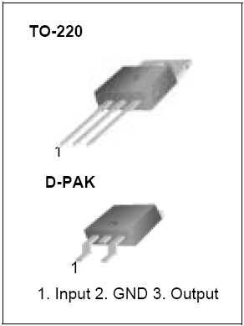

fig 5.9 Voltage Regulator IC 7805

5.3.7 IC 7805 PIN LAYOUT

IC 7805 is used to give a +5V dc supply in the power supply.
The 7805 series of devices is a family of self-contained fixed linear voltage regulator integrated circuit .The 7805 is a very popular choice for many electronic circuits that require a regulated power supply, due to their ease of use and relative cheapness. The 7805 has a 5 volt output as it is dependent on the last two-digit number.7805 ICs have 3 terminals. 7805 ICs have built-in protection against a circuit drawing too much power. 7805 ICs do not require any additional components to provide a constant, regulated source of power, making them easy to use, as well as economical, and also efficient uses of circuit board real estate. By contrast, most other voltage regulators require several additional components to set the output voltage level, or to assist in the regulation process. They also have protection against overheating and short-circuits, making them quite robust in most applications.

Internal Block Diagram:

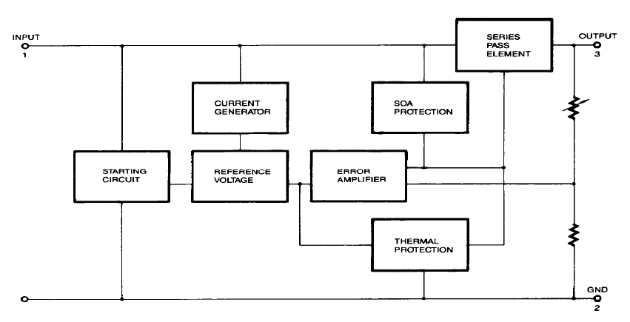fig 5.10 IC 7805 INTERNAL BLOCK DIAGRAM
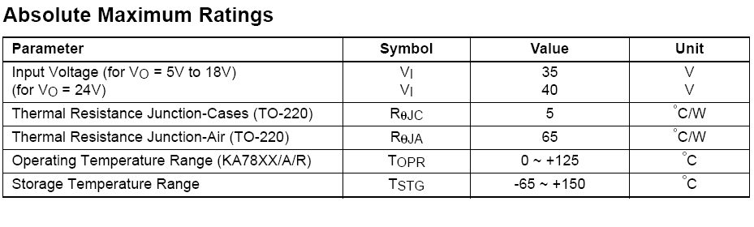
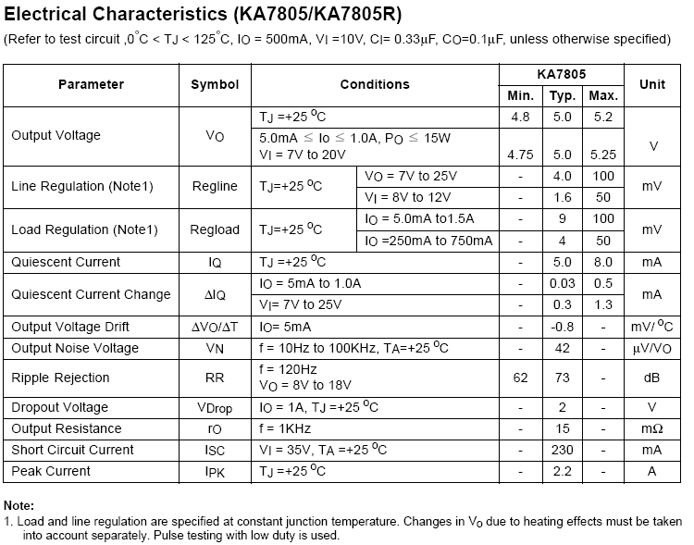

IC 7805 ELECTRICAL CHARACTERISTIC

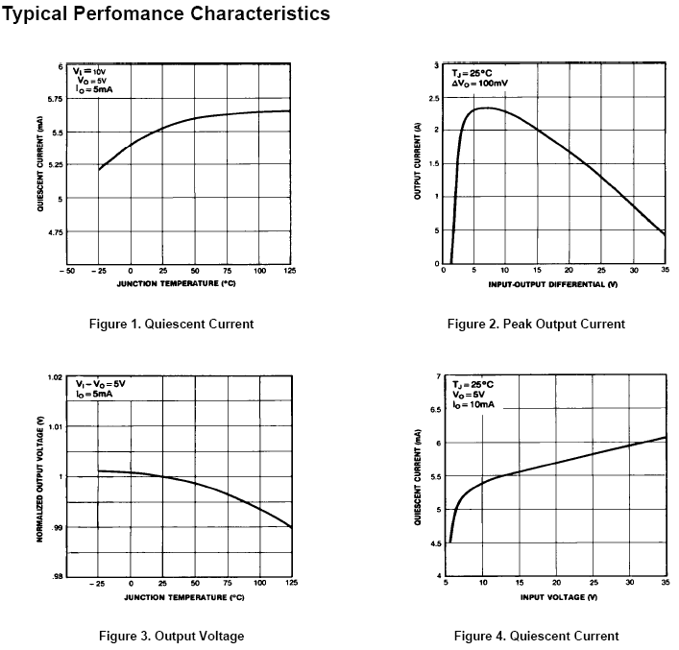
fig 5.11 IC 7805 CHARACTERISTICS

5.3.8 GSM TECHNOLOGY
INTRODUCTION
Consider the basic electrical parameters. That electrical parameters are all controlled by wired system but the recent trend the wireless communication is replaced by wired system which was very messy and difficult to setup how ever, the existing wireless system can cover up to certain range of area that is limited by the range of wireless module being used. This paper introduces the conceptual understanding and strategy of GSM standard to be deployed in any environment. GSM will provide unlimited range of communication for the system as long as there are intermediate nodes that will pass the data from one node to another until it reaches the destination. Prototype systems of electrical device switching are built utilizing GSM based sensor network to present an insight for its practical implementation in smart home concept.
GSM (GLOBAL SYSTEM FOR MOBILES)
The product is available as Board Level or enclosed in Metal Box. The Board Level product can be integrated in to Various Serial devices in providing those SMS and Data capability and the unit housed in a Metal Enclosure can be kept outside to provide serial port connection. The GSM Modem supports popular "AT" command set so that users can develop applications quickly.
The product has SIM Card holder to which activated SIM card is inserted for normal use. The power to this unit can be given from UPS to provide uninterrupted operation. This product provides great feasibility for Devices in remote location to stay connected which otherwise would not have been possible where telephone lines do not exist.

Details of “AT” (Attention) Commands:
AT commands are instructions used to control a modem. AT is the abbreviation of Attention. Every command line starts with "AT" or "at". That’s why modem commands are called AT commands. There are two types of AT commands.
Basic commands are AT commands that do not start with "+". For example, D (Dial), A (Answer), H (Hook control) and O (Return to online data state) are basic commands.

Extended commands are AT commands that start with "+". All GSM AT commands are extended commands. For example, +CMGS (Send SMS message), +CMGL (List SMS messages) and +CMGR (Read SMS messages) are extended commands.
GSM modem (900/1800 MHz) Semen’s GSM/GPRS Smart Modem is a multi-functional, ready to use, rugged unit that can be embedded or plugged into any application. The Smart Modem can be controlled and customized to various levels by using the standard AT commands. The modem is fully type-approved, it can speed up the operational time with full range of Voice, Data, Fax and Short Messages (Point to Point and Cell Broadcast), the modem also supports GPRS (Class 2*) for spontaneous data transfer. Description of the interfaces The modem comprises several interfaces: - LED Function including operating Status - External antenna ( via SMA) - Serial and control link - Power Supply ( Via 2 pin Phoenix tm contact ) - SIM card holder

Application Of GSM
- Mobile Transport vehicles.
- LAN based SMS servers
- Alarm notification of critical events including Servers
- Network Monitoring and SMS reporting
- Data Transfer applications from remote locations
- Monitor and control of Serial services through GSM Network
- Integration to custom software for Warehouse, Stock, Production,
- Dispatch notification through SMS.
- AMR- Automatic Meter Reading.

CONNECTION DIAGRAM
fig 5.12 Connection Diagram
Supply Input
The product requires AC supply of 9 V with 1 Amp current rating for proper Operation.

GSM Serial
This RS 232 serial port can be connected to computer or any serial port for communicating with the product using AT commands. Default Port Speed is 9600 bps.

BLOCK DIAGRAM:
fig 5.13 Block Diagram of GSM model

Power ON LED Indication
Always On when there is Power available to the unit
GSM Status LED
OFF – Module is in OFF mode or under download condition
Slow Flash – ON 200 msec and OFF 2 sec – Unit is registered on the Network and there is No data transfer.
Quick Flash – ON 200 ms and OFF 600 m sec – Unit is registered on the Network and data transfer is in Progress.
SIM Card Holder
Insert the Activated SIM card from the GSM service provider in this socket for Normal operation.

RJ 9 Jack for Handset Connection
Insert Analog Telephone instrument Handset with RJ 9 plug to this socket for Voice communication.
Advantages:
- It is very safe and secure to use.
- Fast, effective and flawless service.
- We can control any appliances remotely.
- Highly-reliable and efficient to use.
Disadvantage:
If network busy the delivery of SMS may fail, so it’s difficult to control the appliances.

5.3.9 RELAYS
We are using relay in our project to switch ON/OFF any electrical devices. These relay are switched ON/OFF by sending control signal from microcontroller. The output from these relay can be used to operate any electrical device of suitable volt-ampere rating.
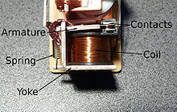
Fig 5.14. Relays
A relay is an electrically operated switch. Many relays use an electromagnet to operate a switching mechanism mechanically, but other operating principles are also used. Relays are used where it is necessary to control a circuit by a low-power signal (with complete electrical isolation between control and controlled circuits), or where several circuits must be controlled by one signal. The first relays were used in long distance telegraph circuits, repeating the signal coming in from one circuit and re-transmitting it to another. Relays were used extensively in telephone exchanges and early computers to perform logical operations.
A type of relay that can handle the high power required to directly drive an electric motor is called a contractor. Solid-state relays control power circuits with no moving parts, instead using a semiconductor device to perform switching. Relays with calibrated operating characteristics and sometimes multiple operating coils are used to protect electrical circuits from overload or faults; in modern electric power systems these functions are performed by digital instruments still called "protective relays".
ADVANTAGES OF RELAYS
Relays can switch AC and DC, transistors can only switch DC.
Relays can switch higher voltages than standard transistors.
Relays are often a better choice for switching large currents (> 5A).
Relays can switch many contacts at once.
DISADVANTAGES OF RELAYS
Relays are bulkier than transistors for switching small currents.
Relays cannot switch rapidly (except reed relays), transistors can switch many times per second.
Relays use more power due to the current flowing through their coil.
5.3.10 POWER SUPPLY SECTION:
In-order to work with any components basic requirement is power supply. In this section there is a requirement of 5V power supply.
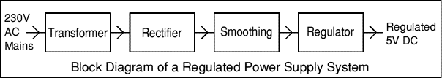

TRANSFORMERS convert AC electricity from one voltage

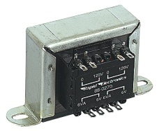

fig 5.15 Transformer
to another with little loss of power. Transformers work only with AC and this is one of the reasons why mains electricity is AC.
Step-up transformers increase voltage, step-down transformers reduce voltage. Most power supplies use a step-down transformer to reduce the dangerously high mains voltage (230V in UK) to a safer low voltage.
A Bridge Rectifier can be made using four individual diodes, but it is also available in special packages containing the four diodes required. It is called a full-wave rectifier because it uses all the AC wave (both positive and negative sections
By the electrolytic Capacitor connected across the DC supply to act as a reservoir, Smoothing is performed by a large value supplying current to the output when the varying DC voltage from the rectifier is falling
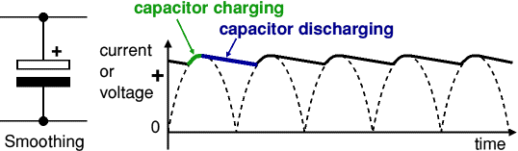

5.3.11 EEPROM AT24C04

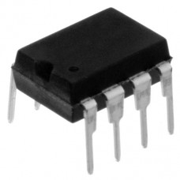
fig 5.16 EEPROM AT24C04

The AT24C04 provides 4096 bits (4k Bytes) of serial electrically erasable and programmable read-only memory (EEPROM) organized as 512 words of 8 bits each. The device is optimized for use in many industrial and commercial applications where low-power and low-voltage operation are essential.

CHEPTER 6
TEST CASES

- TEST CASES

Testing Methods
System testing is a critical phase implementation. Testing of the system involves hardware devise and debugging of the computer programs and testing information processing procedures. Testing can be done with text data, which attempts to stimulate all possible conditions that may arise during processing. If structured programming Methodologies have been adopted during coding the testing proceeds from higher level to lower level of program module until the entire program is tested as unit. The testing methods adopted during the testing of the system were unit testing and integrated testing.
Unit Testing:
Unit testing focuses first on the modules, independently of one another, to locate errors. This enables the tester to detect errors in coding and logical errors that is contained within that module alone. Those resulting from the interaction between modules are initially avoided.
Integration Testing:
Integration testing is a systematic technique for constructing the program structure while at the same time to uncover the errors associated with interfacing. The objective is to take unit-tested module and build a program structure that has been detected by designing. It also tests to find the discrepancies between the system and its original objectives. Subordinate stubs are replaced one at time actual module. Tests were conducted at each module was integrated. On completion of each set another stub was replaced with the real module.
Functional Testing:
Functional testing is a technique in which all the functionalities of the program are tested to check whether all the functions that where proposed during the planning phase are full filled.
This is also to check that if all the functions proposed are working properly.
This is further done in two phases:
- One before the integration to see if all the unit components work properly
- Second to see if they still work properly after they have been integrated to check if some functional compatibility issues arise.

6.1. GRAPHICAL USER INTERFACE
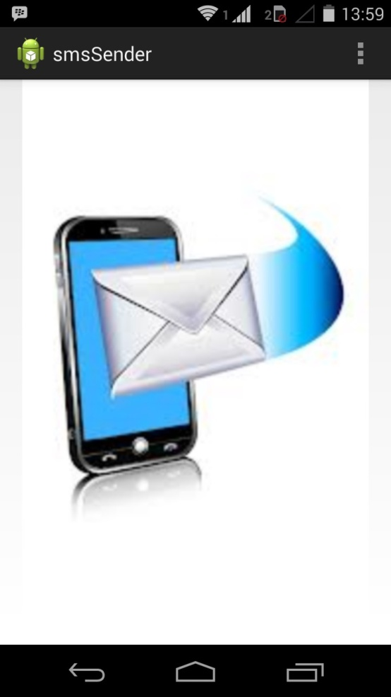

fig 6.1 GUI(I)

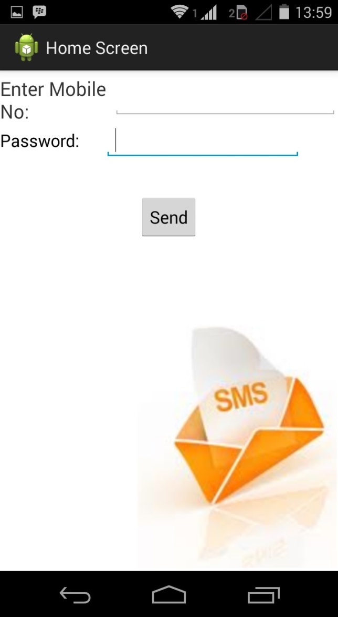

fig 6.2 GUI(II)

CHEPTER 7

CONCLUSION AND FUTURE WORK

7. CONCLUSION AND FUTURE WORK

In the paper low cost, secure, ubiquitously accessible, auto-configurable, remotely controlled solution for automation of homes has been introduced. The approach discussed in the paper is novel and has achieved the target to control home appliances remotely using the SMS-based system satisfying user needs and requirements.
GSM technology capable solution has proved to be controlled remotely, provide home security and is cost-effective as compared to the previously existing systems. Hence we can conclude that the required goals and objectives of our project have been achieved.
The basic level of home appliance control and remote monitoring has been implemented. The system is extensible and more levels can be further developed using automatic motion/glass breaking detectors so the solution can be integrated with these and other detection systems.

7.1 FUTURE DEVELOPMENT:
1) Voice announcement system can be added to indicate device conditions. We can add voice announcement system along with the buzzer so if there are hazardous parameters detected then respective voice message will be announced.
2) We can add fingerprint sensor instead of password based door operating. So entry will be allowed for the authorized person using their fingerprints.
3) We can monitor and control more parameters and devices.We can implement other related modules like fire sensor, wind sensor

APPENDIX A:
CLASSES AND EXTERNAL LIBRARIES

APPENDIX A:CLASSES AND EXTERNAL LIBRARIES
package com.myApp.smssender;

public final class R {
public static final class attr {
}
public static final class drawable {
public static final int ic_launcher=0x7f020000;
public static final int ic_splash_sms=0x7f020001;
public static final int sms_background=0x7f020002;
public static final int splash=0x7f020003;
}
public static final class id {
public static final int btnHospital=0x7f070002;
public static final int editPwd=0x7f070004;
public static final int edtphoneNo=0x7f070001;
public static final int img=0x7f070006;
public static final int imgsplash=0x7f070005;
public static final int linearLayout1=0x7f070000;
public static final int menu_settings=0x7f070007;
public static final int textView1=0x7f070003;
}
public static final class layout {
public static final int activity_main=0x7f030000;
public static final int loading=0x7f030001;
public static final int splash=0x7f030002;
public static final int splash1=0x7f030003;
}
public static final class menu {
public static final int activity_main=0x7f060000;
}
public static final class string {
public static final int app_name=0x7f040000;
public static final int hello_world=0x7f040001;
public static final int menu_settings=0x7f040002;
}
public static final class style {
/**
Base application theme, dependent on API level. This theme is replaced
by AppBaseTheme from res/values-vXX/styles.xml on newer devices.

Theme customizations available in newer API levels can go in
res/values-vXX/styles.xml, while customizations related to
backward-compatibility can go here.

Base application theme for API 11+. This theme completely replaces
AppBaseTheme from res/values/styles.xml on API 11+ devices.

API 11 theme customizations can go here.

Base application theme for API 14+. This theme completely replaces
AppBaseTheme from BOTH res/values/styles.xml and
res/values-v11/styles.xml on API 14+ devices.

API 14 theme customizations can go here.
*/
public static final int AppBaseTheme=0x7f050000;
/** Application theme.
All customizations that are NOT specific to a particular API-level can go here.
*/
public static final int AppTheme=0x7f050001;
}
}

BIBLIOGRAPHY

BIBLIOGRAPHY:
1. “Applied Electronics” by R.S.Sedha, S.Chand &company Ltd.
2. Details of 8051 microcontroller & Embedded systems, Muhammad Ali Mazidi, Pearson education. & www.8051projects.net.
3. Hardware & Software of 8051 microcontroller by William Kleitz, Pearson Education.
4. Electronics Instrumentation by H.S.Kalshi, Tata Mc Grawhill.
5. Programming in embedded ‘c’ By David E.Simon, pearson Education.
6. Linear integrated circuits by D.Roy Chodhary, Shile B.Jani.
7. www.datasheet4u.com&
8. www.Alldatasheet.com.

